**MERCIADO AMUSEMENT PARK**

**BATCH CODE: 2206 F1**

**Documentation**

**DEVELOPER GUIDE**

**GROUP MEMBER:**

|  |  |
| --- | --- |
| **ABDULLAH KAMAL** | **Student1345289** |
| **ARHAM RAO** | **Student1388281** |
| **MUHAMMAD AHSAN MAZHAR** | **Student1386879** |
| **MUHAMMAD DANIYAL** | **Student1386877** |

TABLE OF CONTENT:

**HOME PAGE:**

CODE FOR HEADER:

CODE FOR CENTER PORTION:

CODE FOR FOOTER:

**CATEGORIES:**

CODE FOR NAV BAR:

CODE OF MAINBODY:

SUB CATEGORIES:

CODE OF MAIN BODY:

**GALLERY:**

**contact us**

Code: [68](https://docs.google.com/document/d/1o2oYPK_5E2fQZsXaJyce0Gz8GbW3dVzU/edit#heading=h.44sinio)

**CODE FOR FORM:**

**FOOTER**

Restaurants

ABOUT US:



HOME PAGE:

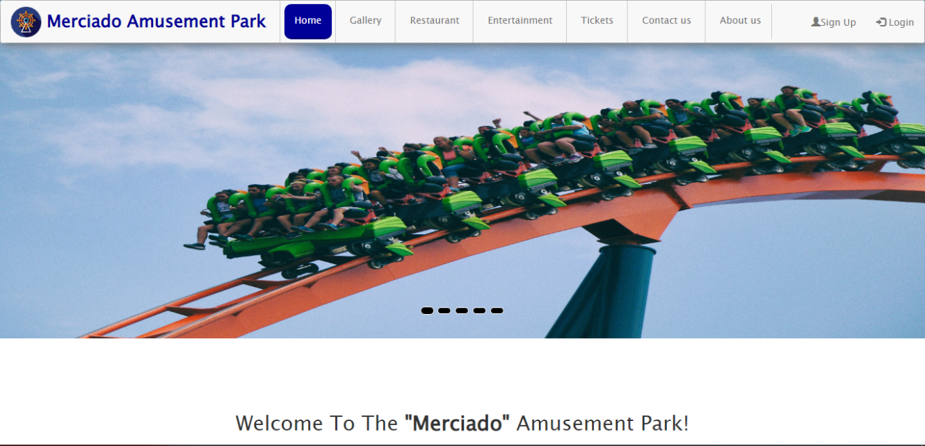

**CODING OF HEADER**

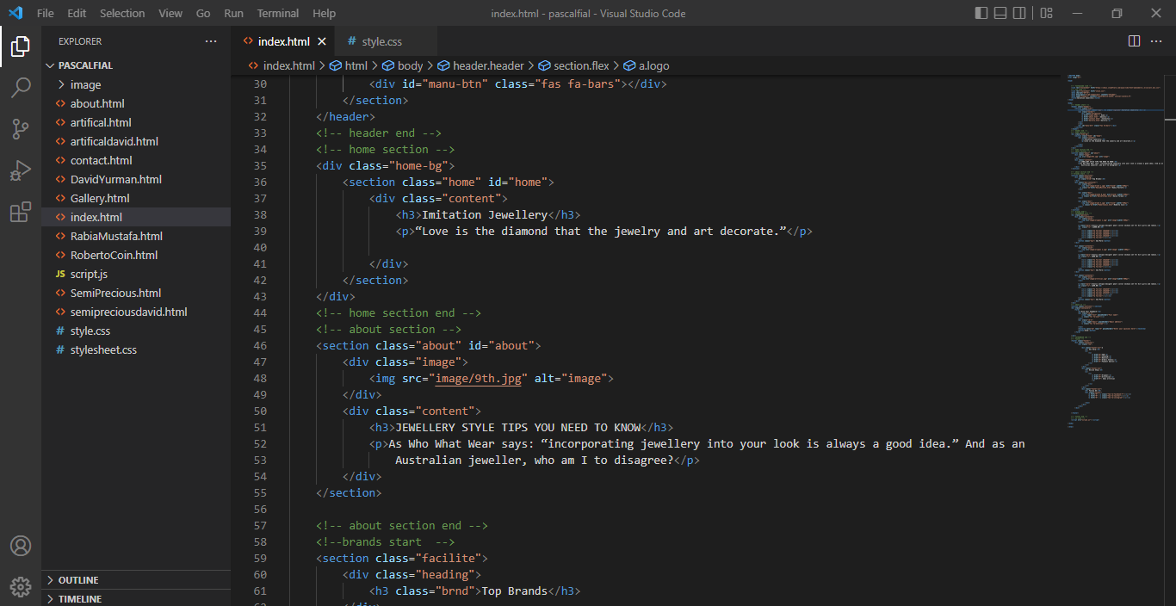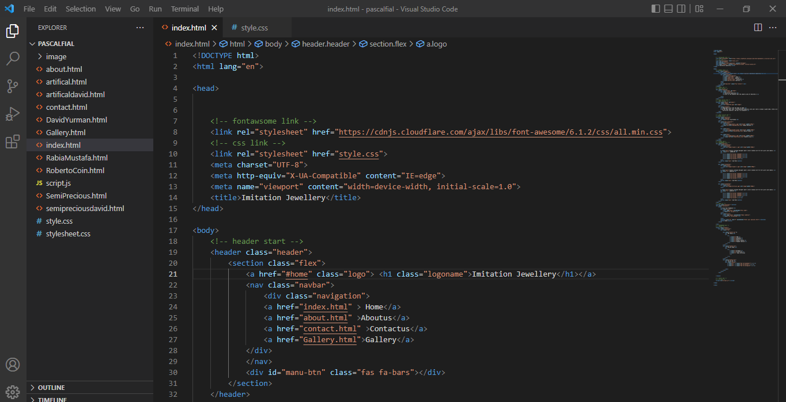

HOME:

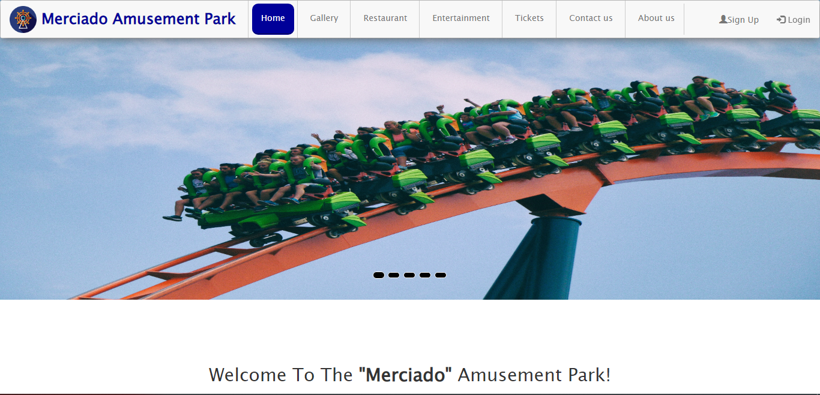

**CODING OF HOME**

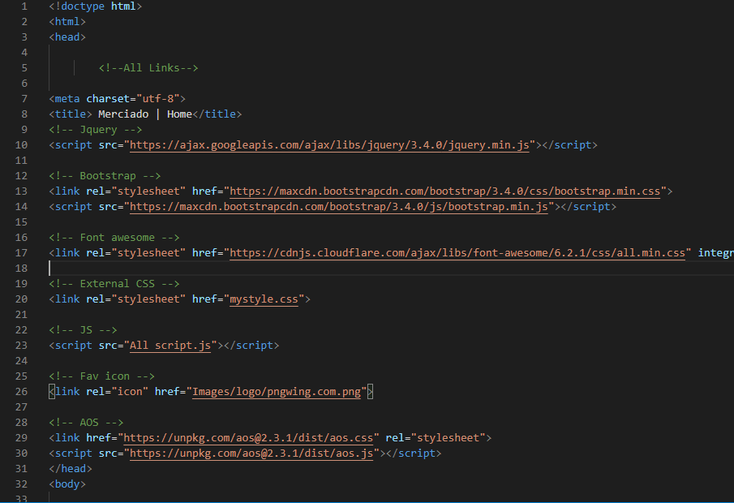

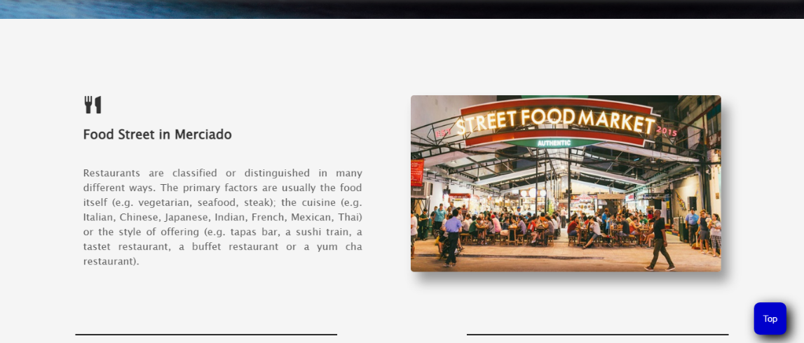

**CODING OF TOP Restaurants**

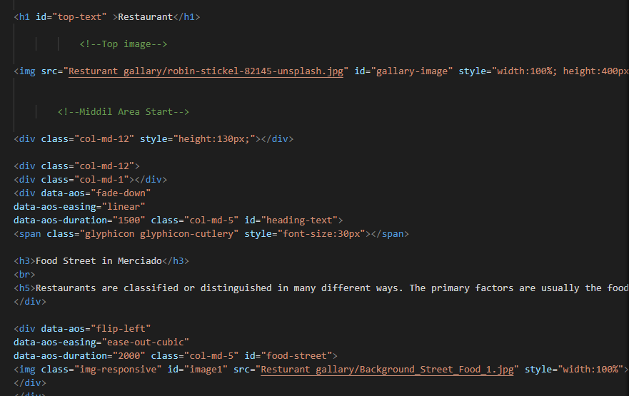

FOOTER:

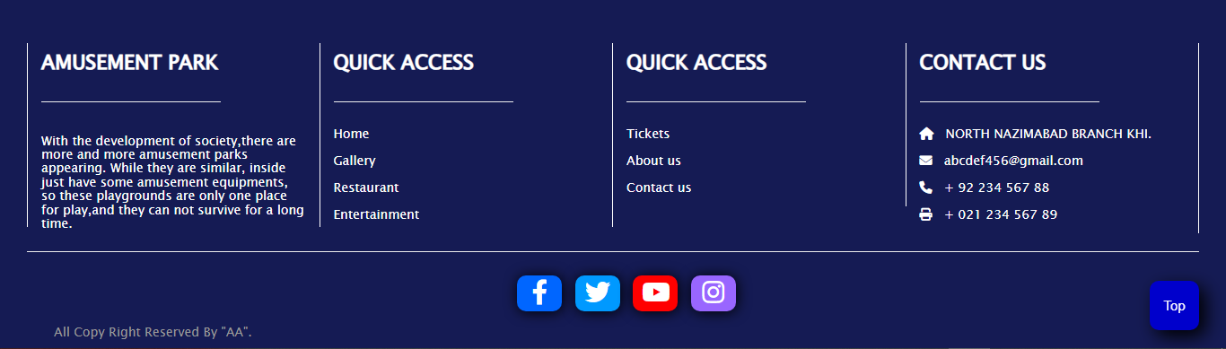

**CODING OF FOOTER**

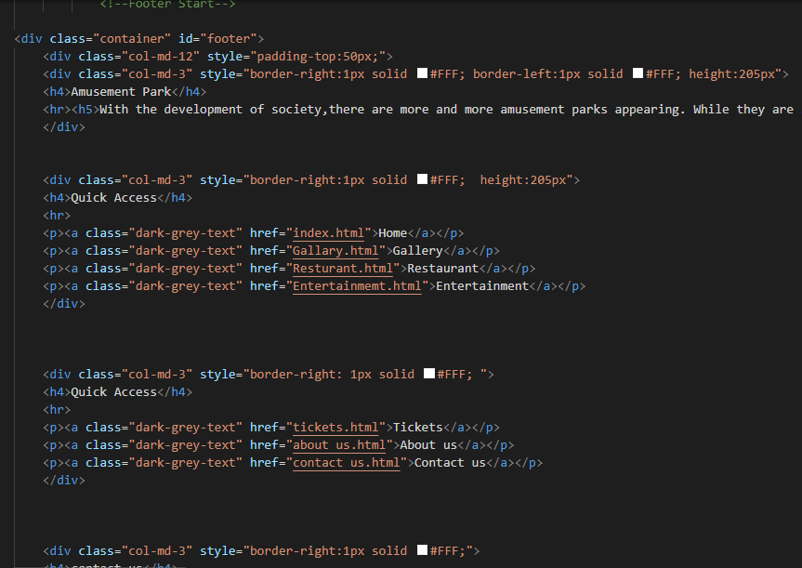

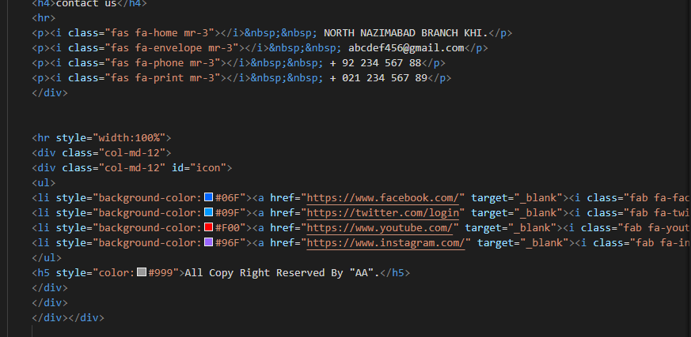

ABOUT US:

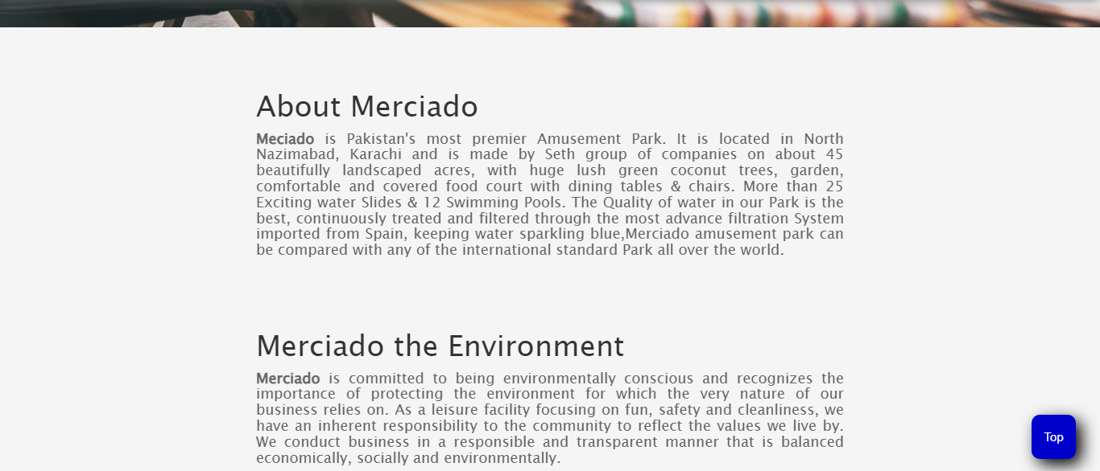

**CODING OF ABOUT US**

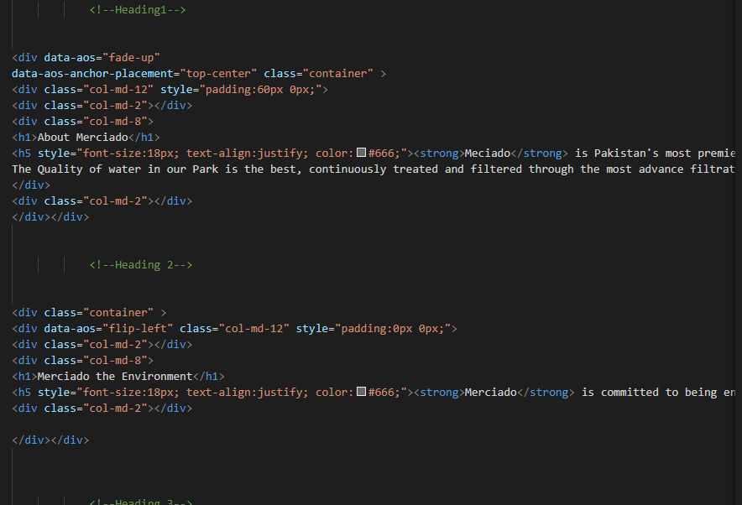

CONTACT US:

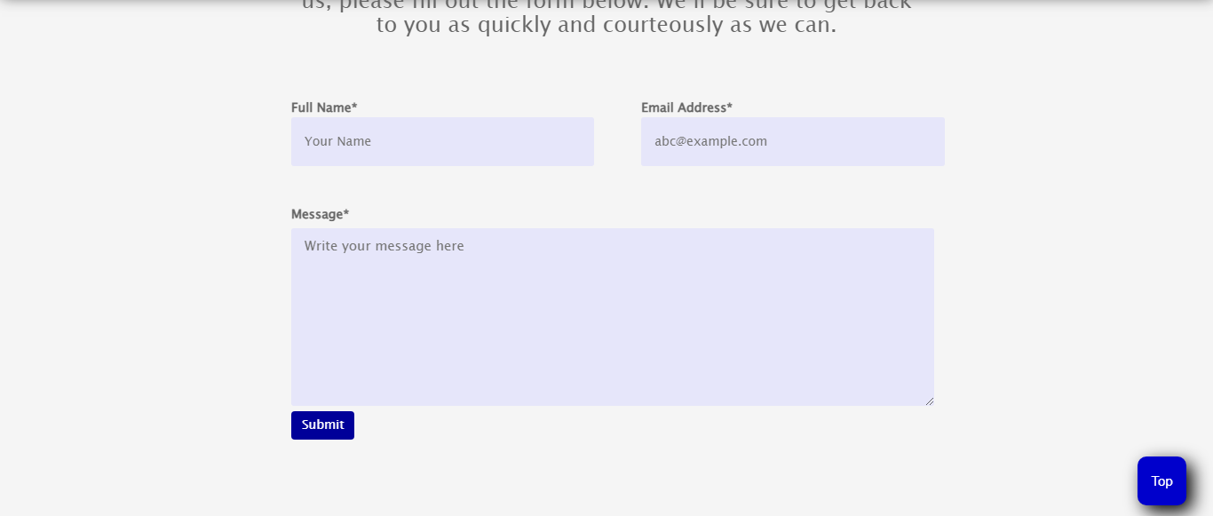

**CODING OF CONTACT US**

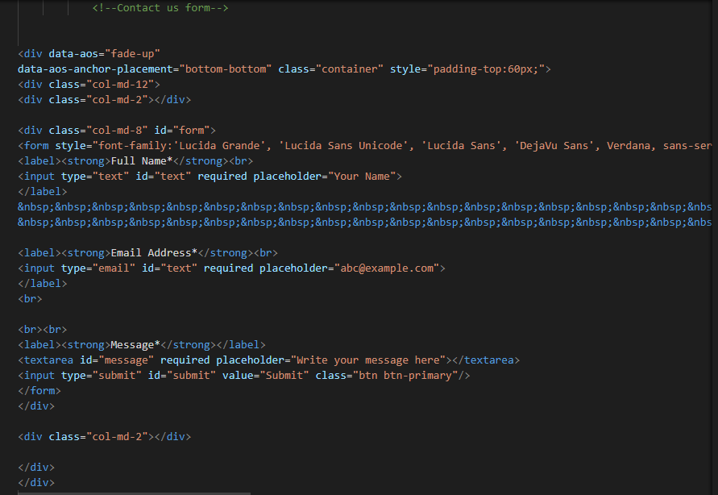

GALLERY SECTION:

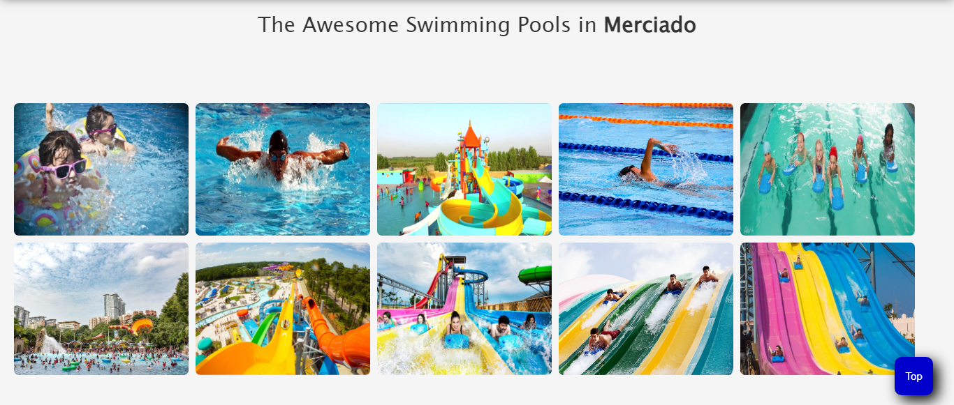

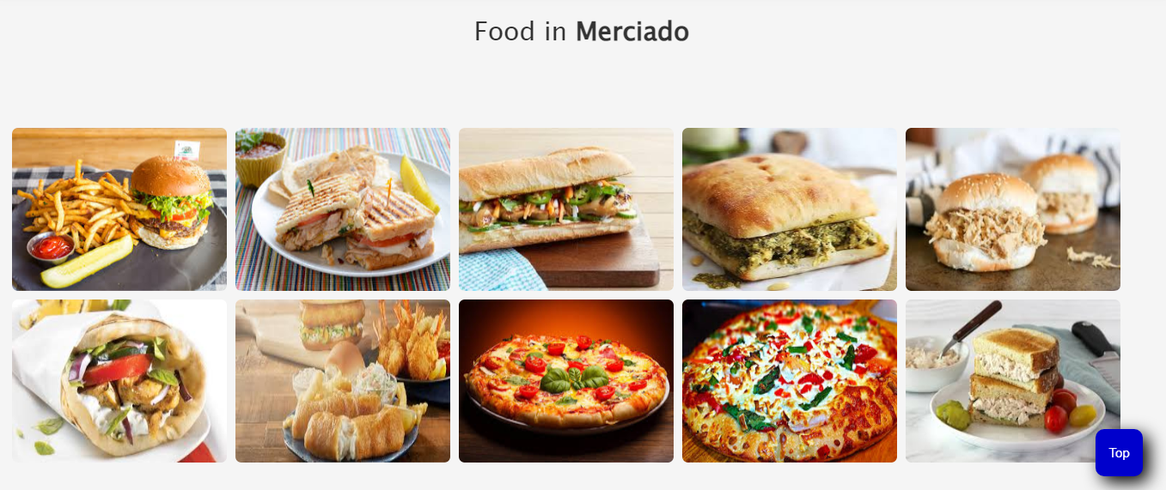

**CODING OF GALLERY SECTION**

